Submitted By:
Name: Ayusmeeta Sahoo
Superset ID: 7844623
Roll No. 2301020017
Email ID: ayusmeetasahoo@gmail.com
C. V. Raman Global University, Bhubaneswar, Odisha

EF Core 8.0 Guided Hands-On Exercises

Lab 1: Understanding ORM with a Retail Inventory System

Scenario:
Building an inventory management system for a retail store. The store wants to track products, categories, and stock levels in a SQL Server database.
Objective:
Understanding what ORM is and how EF Core helps bridge the gap between C# objects and relational tables.
Steps:

What is ORM?
  - Explain how ORM maps C# classes to database tables.
  - Benefits: Productivity, maintainability, and abstraction from SQL.
Ans. ORM (Object Relational Mapping) is a technique that maps C# classes to database tables. It allows developers to perform database operations using C# objects instead of writing SQL queries manually.
Benefits of ORM:
- Productivity: Reduces the amount of SQL code developers need to write.
- Maintainability: Changes in the application model are easier to manage.
- Abstraction from SQL: Developers work with C# objects while EF Core automatically generates SQL queries.

EF Core vs EF Framework:
EF Core is cross-platform, lightweight, and supports modern features like LINQ, async queries, and compiled queries.
EF Framework (EF6) is Windows-only and more mature but less flexible.

EF Core 8.0 Features:
  - JSON column mapping.
  - Improved performance with compiled models.
  - Interceptors and better bulk operations.

Create a .NET Console App:
dotnet new console -n RetailInventory cd RetailInventory

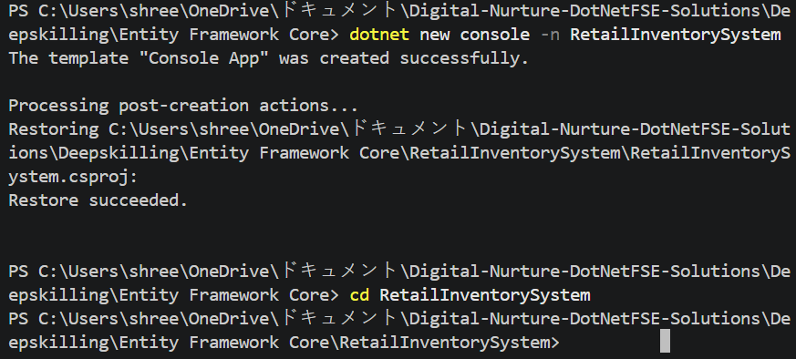

Install EF Core Packages:

dotnet add package Microsoft.EntityFrameworkCore.SqlServer dotnet add package Microsoft.EntityFrameworkCore.Design

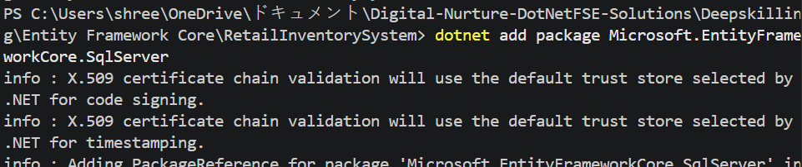

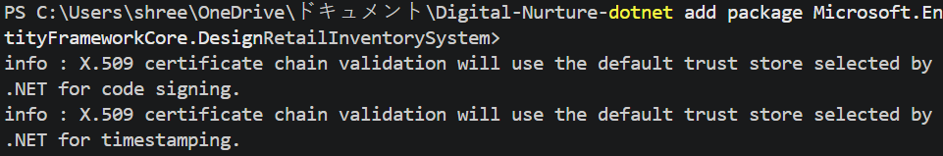

Lab 2: Setting Up the Database Context for a Retail Store
Scenario:
The retail store wants to store product and category data in SQL Server.
Objective:
Configure DbContext and connect to SQL Server.
Steps:

Create Models:
public class Category { public int Id { get; set; }
public string Name { get; set; } public List Products { get; set; }
}
public class Product {
public int Id { get; set; }
public string Name { get; set; } public decimal Price { get; set; } public int CategoryId { get; set; }
public Category Category { get; set; }
}
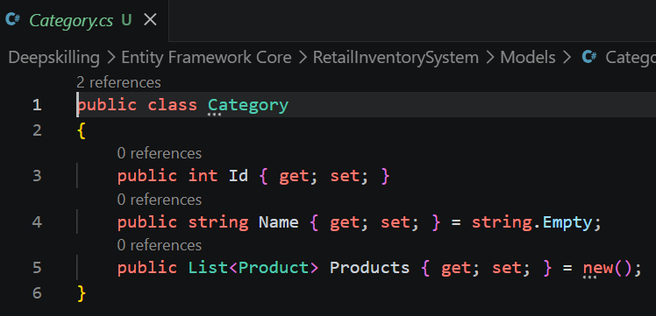
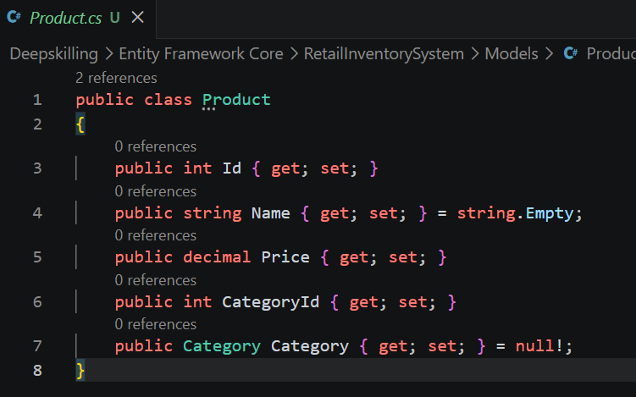

Create AppDbContext:
public class AppDbContext : DbContext { public DbSet Products { get; set; }
public DbSet Categories { get; set; }
protected override void OnConfiguring(DbContextOptionsBuilder optionsBuild er) {
optionsBuilder.UseSqlServer("Your_Connection_String_Here");
}
}
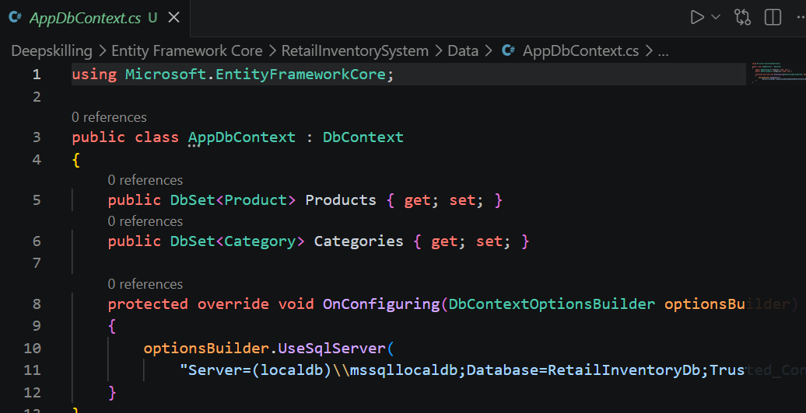

- Add Connection String in appsettings.json (optional for ASP.NET Core).

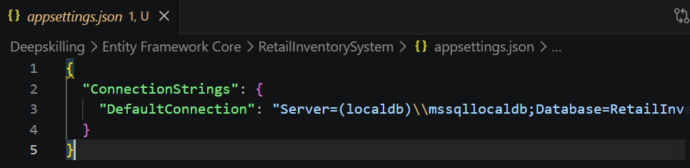

Lab 3: Using EF Core CLI to Create and Apply Migrations

Scenario:
The retail store's database needs to be created based on the models you've defined. You’ll use EF Core CLI to generate and apply migrations.
Objective:
Learn how to use EF Core CLI to manage database schema changes.
Steps:

Install EF Core CLI (if not already):
dotnet tool install --global dotnet-ef

Create Initial Migration:
dotnet ef migrations add InitialCreate This generates a Migrations folder with code that represents the schema.
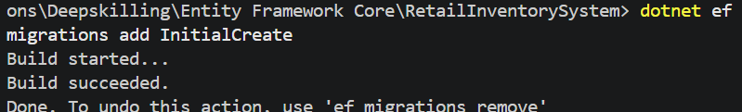

Apply Migration to Create Database:
dotnet ef database update

Verify in SQL Server:
Open SQL Server Management Studio (SSMS) or Azure Data Studio and confirm that tables Products and Categories are created.
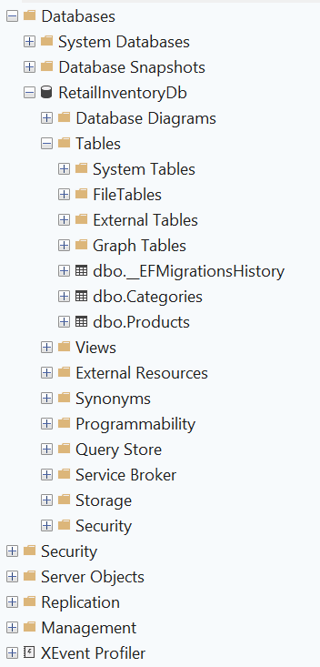
Lab 4: Inserting Initial Data into the Database

Scenario:
The store manager wants to add initial product categories and products to the system.

Objective:
Use EF Core to insert records using AddAsync and SaveChangesAsync.

Steps:

Insert Data in Program.cs
using var context = new AppDbContext();

var electronics = new Category { Name = "Electronics" }; var groceries = new Category { Name = "Groceries" };

await context.Categories.AddRangeAsync(electronics, groceries);

var product1 = new Product { Name = "Laptop", Price = 75000, Category = electro nics };
var product2 = new Product { Name = "Rice Bag", Price = 1200, Category = groceri es };

await context.Products.AddRangeAsync(product1, product2); await context.SaveChangesAsync();

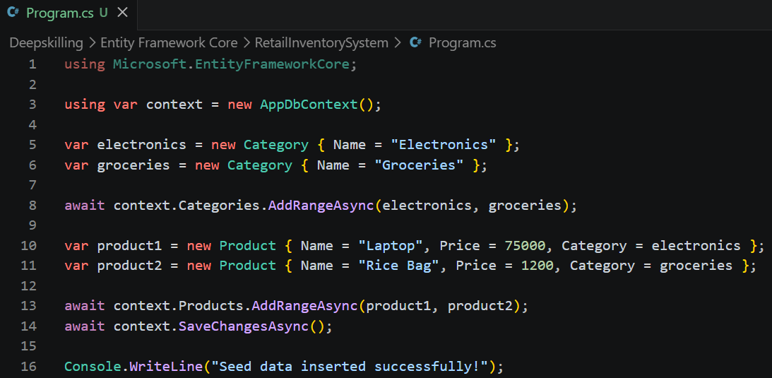

Run the App:
dotnet run

Verify in SQL Server:
Check that the data is inserted correctly.

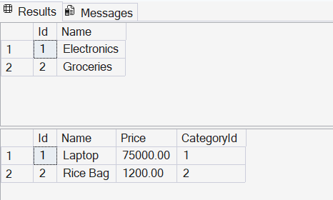

Lab 5: Retrieving Data from the Database

Scenario:
The store wants to display product details on the dashboard.

Objective:
Use Find, FirstOrDefault, and ToListAsync to retrieve data.

Steps:

Retrieve All Products:
var products = await context.Products.ToListAsync(); foreach (var p in products)
Console.WriteLine($"{p.Name} - ₹{p.Price}");

Find by ID:
var product = await context.Products.FindAsync(1); Console.WriteLine($"Found: {product?.Name}");

FirstOrDefault with Condition:
var expensive = await context.Products.FirstOrDefaultAsync(p => p.Price > 5000 0);
Console.WriteLine($"Expensive: {expensive?.Name}");

